SMART-AGRO: ENHANCING CROP MANAGEMENT WITH AGRIBOT
Krishna Prasath VT, Sushanth Reddy G, Krishna kaanth K, Madanmohan Reddy K
Associate Professor, Department of Artificial Intelligence and Data Science, Nehru Institute of
Engineering and Technology, Anna University, Coimbatore, India
UG Student, Department of Artificial Intelligence and Data Science, Nehru Institute of
Engineering and Technology, Anna University, Coimbatore, India

*Corresponding Author: prasathkriss@gmail.com

ABSTRACT

The Agri-Bot Robotic system indeed represents a significant advancement in modern agriculture, offering a multifaceted solution for monitoring and managing agricultural environments. By integrating various Arduino-based sensors and motor drivers, it provides a comprehensive toolkit for farmers to effectively oversee their crops' health and optimize resource usage. The inclusion of pH and moisture sensors enables real-time monitoring of soil conditions, allowing farmers to adjust irrigation and fertilizer application precisely according to the plants' needs. Additionally, the DHT11 sensor offers insights into ambient conditions crucial for plant growth, such as temperature and humidity, facilitating informed decision-making. The incorporation of the L298 motor driver further enhances the system's capabilities by enabling automation of tasks like irrigation and seed sowing with precision and efficiency. This integration of robotics and sensor technology not only streamlines agricultural processes but also empowers farmers with data-driven insights to optimize crop growth and sustainability.

Keywords: Agri-Bot ,Crop Management ,IoT (Internet of Things) ,Robotics, Data Analytics ,Precision Agriculture, Sustainability ,Sensor Networks ,Renewable Energy ,Decision-making ,Environmental Impact ,Labor Costs ,Precision Farming ,Responsible Agriculture ,Food Security ,Efficiency.

INTRODUCTION

AgriBot Robotics is revolutionizing agriculture with its cutting-edge technology, particularly through its Arduino-based sensor array and automation mechanisms. By monitoring crucial environmental parameters like pH levels and soil moisture in real-time, AgriBot provides farmers with invaluable data for informed decision-making, leading to enhanced crop yields. Its advanced control systems, including the L298 motor driver for pump and seed sowing management, automate labor-intensive tasks such as irrigation and seed sowing, boosting efficiency and productivity while minimizing human error. AgriBot represents a paradigm shift in agricultural management, merging robotics with agriculture to optimize precision, efficiency, and sustainability for the future of farming.

MATERIALS AND METHODS

"Smart-Agro: Enhancing Crop Management with AgriBot" integrates advanced methods and materials to revolutionize traditional farming practices. At its core, the system employs sophisticated data collection and analysis techniques, facilitated by a network of sensors strategically placed throughout the agricultural fields. These sensors, including moisture sensors, temperature sensors, and humidity sensors, continuously gather vital environmental data. By analyzing this data, farmers gain valuable insights into soil moisture levels, temperature variations, and humidity conditions, empowering them to make data-driven decisions about irrigation scheduling, fertilizer application, and pest management.

Central to the Smart-Agro system is the utilization of automation and robotics, exemplified by the AgriBot. This robotic platform, equipped with Arduino-based microcontrollers, motors, actuators, and an array of sensors, is designed to perform a myriad of farming tasks autonomously. From planting and weeding to spraying pesticides and harvesting, the AgriBot operates efficiently and precisely, minimizing labor requirements while maximizing productivity. Through the integration of precision agriculture techniques, the AgriBot can tailor its actions to the specific needs of individual plants or sections of the field, optimizing resource allocation and minimizing waste.

Moreover, Smart-Agro leverages the power of remote monitoring and control, facilitated by IoT technology. This enables farmers to remotely access real-time data about crop conditions, equipment status, and environmental parameters. With the ability to monitor and control the AgriBot and irrigation systems from anywhere with an internet connection, farmers can make timely interventions and adjustments, ensuring optimal crop health and yield.

In terms of materials, the AgriBot is constructed using robust structural components such as chassis, frames, and mechanical structures, ensuring durability and resilience in outdoor environments. Power is supplied through batteries or rechargeable sources, with the option for renewable energy solutions like solar panels for sustainable operation. Communication devices such as IoT modules enable seamless wireless communication between the AgriBot, central control system, and cloud-based platforms, facilitating data exchange and analysis.

Software and algorithms play a crucial role in the Smart-Agro system, enabling the AgriBot to execute complex tasks and process large volumes of data. Programming languages like C/C++ are used to develop code for controlling the AgriBot's behavior, while machine learning algorithms are employed to analyze sensor data, identify patterns, and make predictions about crop health and yield.

By integrating these advanced methods and materials, Smart-Agro aims to transform traditional farming into a highly efficient, data-driven, and sustainable practice. Through the synergy of automation, precision agriculture, and remote monitoring, Smart-Agro empowers farmers to optimize crop management, increase productivity, and promote environmental stewardship.

LITERATURE REVIEW

Bao, R., & Cheng, T. C. E. (2020). ‘Smart Agriculture: IoT and Data Analytics in Crop Management’ Vol.2, pp.3-16.

This paper study employs a review methodology to analyze the applications of IoT (Internet of Things) and data analytics in crop management within the context of smart agriculture. Through a comprehensive examination of existing literature.

Eze, S. C., Abd-Alhameed, R. A., & Msheliza, N. M. (2020). ‘A Review of Smart Agriculture Solutions Using Internet of Things and Big Data Analytics’. Vol.8, pp.93185-93214.

The paper conducts a thorough review of how the fusion of IoT and big data analytics is reshaping agricultural practices, offering a comprehensive analysis of various smart solutions. By synthesizing available literature, it explores the deployment of IoT devices for data collection across different agricultural domains and delves into the application of big data analytics for deriving actionable insights. Emphasizing benefits like enhanced productivity and sustainability, the review also addresses challenges such as data security and interoperability issues. Overall, it contributes to understanding the evolving landscape of smart agriculture.

Gaire, R., Aslani, F., & Afzal, M. T. (2020). ‘A Review of Internet of Things (IoT) Applications in Precision Agriculture’. Vol.3(3), pp.338-347.

The paper reviews the use of IoT in precision agriculture through a review methodology. It explores how IoT devices and sensors are employed for monitoring various agricultural parameters and how the data collected is used to enhance decision-making processes. The study assesses both the benefits, such as increased yields and improved resource efficiency, and the challenges, associated with the adoption of IoT in precision agriculture. Overall, it provides insights into the current landscape of IoT applications in precision agriculture and suggests avenues for future research and development.

Liakos, K. G., Busato, P., Moshou, D., Pearson, S., & Bochtis, D. (2018). ‘Machine learning in agriculture: A review’, Vol.21, pp.1-55.

Utilizing a review methodology, this study examines the applications of machine learning techniques in agriculture. By synthesizing existing research, the authors analyze how machine learning algorithms are employed to address various agricultural challenges, such as crop prediction, disease detection, and yield optimization.
Nidamanuri, R., Sundar, R. S., & Reddy, M. S. (2020). ‘Smart Farming Techniques Using IoT and Artificial Intelligence: A Review’. Vol.120, pp.1-5.

This study adopts a review methodology to explore smart farming techniques utilizing IoT and artificial intelligence (AI). By reviewing relevant literature, the authors analyze how IoT and AI technologies are applied in smart farming practices, focusing on their potential to enhance productivity, sustainability, and decision-making processes.

Sharma, V., Chouhan, R., & Sharma, G. (2020). ‘Smart Farming with IoT Based Crop Field Monitoring System’, Vol.12, pp.1-6.

Through a review methodology, this study explores smart farming practices using an IoT-based crop field monitoring system. By reviewing relevant literature, the authors analyze how IoT technologies are utilized to develop crop field monitoring systems, focusing on their applications, functionalities, and benefits in enhancing agricultural management.

BLOCK DIAGRAM

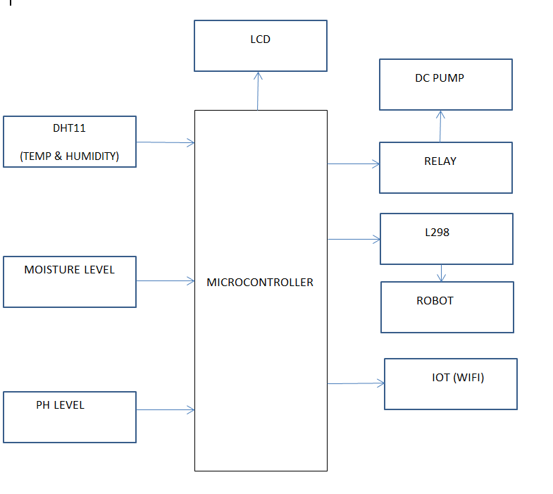

Fig. 1 Block Diagram

RESULTS



Fig. 2 Spraying Water

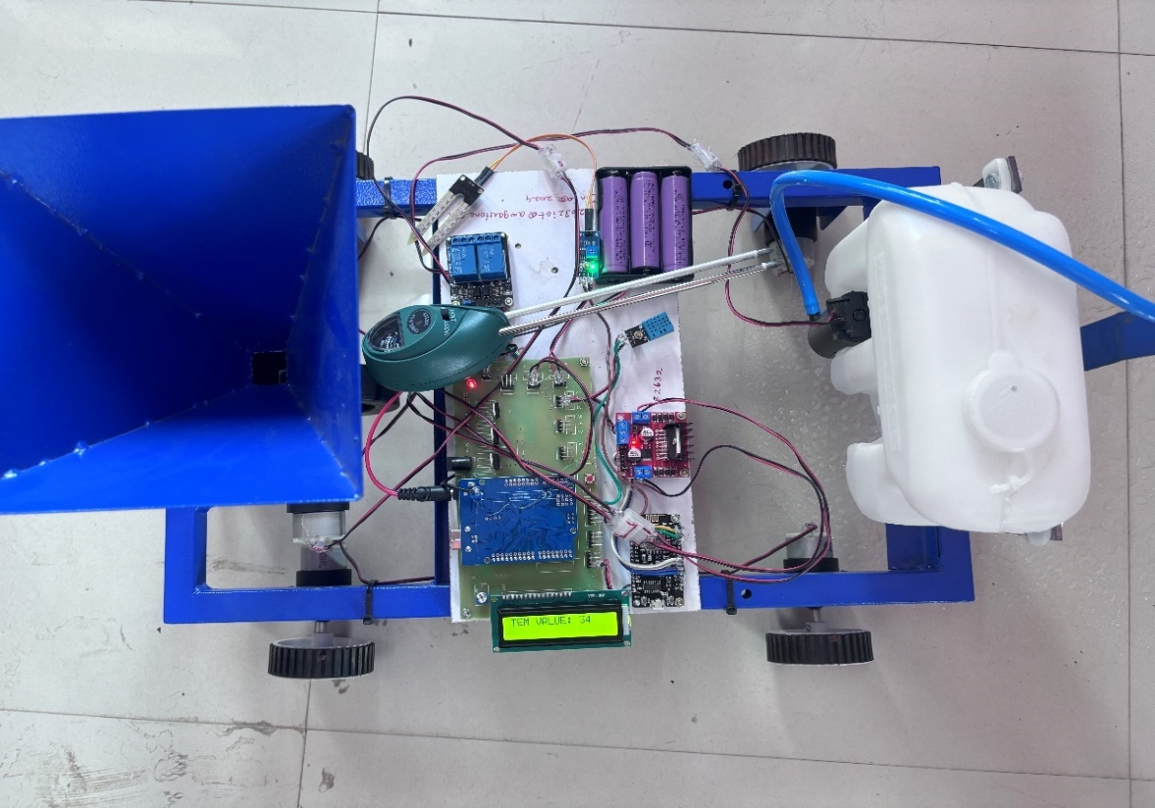
Fig. 3 Top View

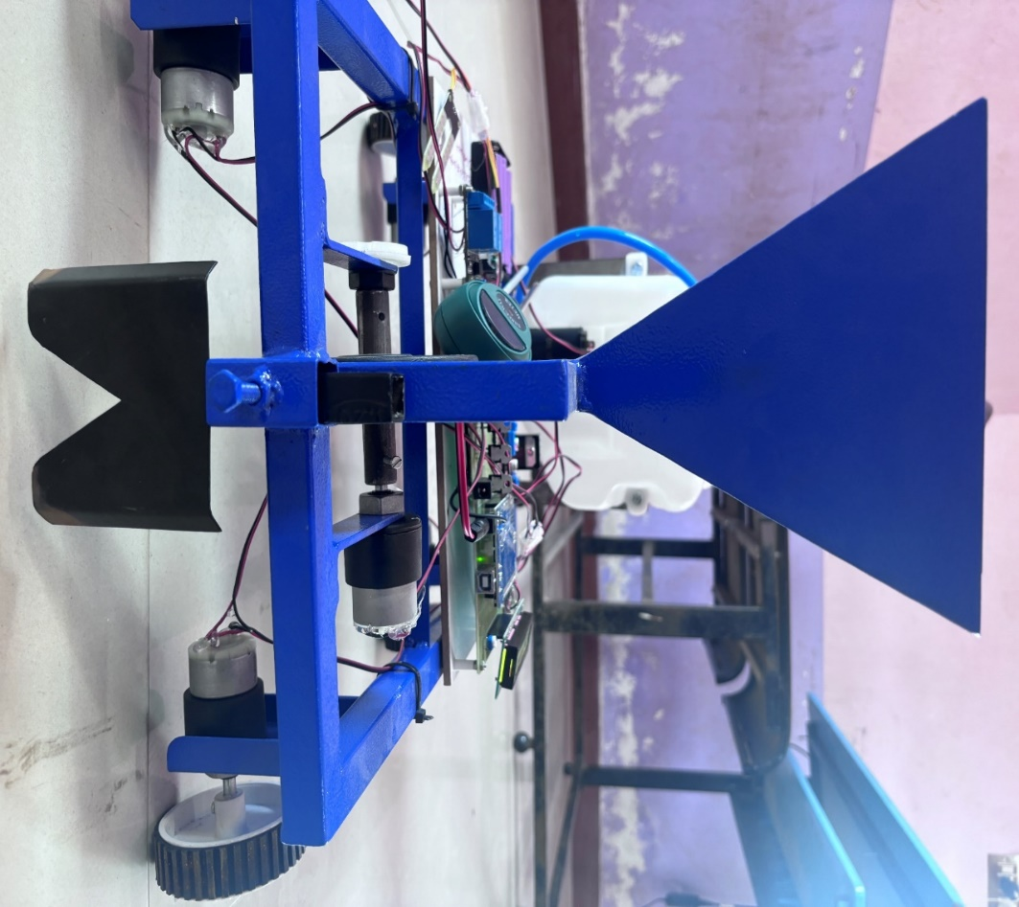
Fig. 4 Seeding And Ploughing

DISCUSSION
The Smart-Agro project represents a pioneering initiative aimed at revolutionizing traditional crop management practices through the deployment of the AgriBot system. At its core, Smart-Agro integrates state-of-the-art technologies, including Internet of Things (IoT), robotics, and sensor technology, to create a sophisticated framework for precision agriculture. The project envisions a future where farmers can leverage data-driven insights and autonomous capabilities to optimize crop cultivation while minimizing resource wastage and environmental impact.One of the key components of the Smart-Agro system is the AgriBot, a versatile robotic platform equipped with an array of sensors and actuators. Designed to operate autonomously in agricultural fields, the AgriBot performs a wide range of tasks, including planting, weeding, monitoring soil conditions, and applying fertilizers or pesticides as needed. By automating these labor-intensive and time-consuming activities, the AgriBot reduces the reliance on manual labor, thereby increasing efficiency and lowering operational costs for farmers.
Central to the success of Smart-Agro is its emphasis on data-driven decision-making. Through the integration of IoT sensors deployed throughout the field and onboard the AgriBot, farmers gain real-time insights into critical parameters such as soil moisture levels, temperature, humidity, and crop health. This wealth of data enables farmers to make informed decisions regarding irrigation schedules, crop treatment strategies, and overall farm management practices, thereby maximizing yield and quality while minimizing inputs.
Moreover, the Smart-Agro project prioritizes sustainability and environmental stewardship. By leveraging renewable energy sources such as solar panels to power the AgriBot and implementing precision irrigation techniques, the project aims to reduce carbon emissions and minimize environmental impact. Additionally, by optimizing resource utilization and minimizing chemical usage through targeted application methods, Smart-Agro promotes eco-friendly farming practices that are both economically viable and environmentally sustainable.
While Smart-Agro represents a significant leap forward in agricultural technology, it also poses various challenges and opportunities for future development. Integration issues, data accuracy, scalability, and cost-effectiveness are among the key challenges that need to be addressed to ensure widespread adoption and success of the system. Nonetheless, with ongoing research, innovation, and collaboration between technology developers, farmers, and agricultural experts, Smart-Agro holds immense promise in shaping the future of sustainable and efficient crop management practices.
CONCLUSION
In conclusion, the Smart-Agro project stands as a beacon of innovation in the realm of agricultural technology, offering a transformative solution to the challenges facing modern farming. Through the implementation of the AgriBot system, this initiative has demonstrated the immense potential of harnessing IoT, robotics, and data analytics to enhance crop management practices.

By leveraging sensor networks and advanced algorithms, Smart-Agro has enabled farmers to make informed decisions in real-time, optimizing resource allocation and improving productivity. The AgriBot's ability to autonomously perform tasks such as seeding, fertilizing, and pest control with precision has not only streamlined operations but also reduced labor costs and minimized environmental impact.Furthermore, the project's emphasis on sustainability, evidenced by the integration of renewable energy sources, underscores its commitment to responsible agricultural practices. By minimizing resource wastage and maximizing crop yield, Smart-Agro not only benefits farmers economically but also contributes to the long-term viability of agricultural ecosystems.

In essence, Smart-Agro represents more than just a technological innovation; it symbolizes a paradigm shift in agricultural practices, embracing data-driven decision-making and precision agriculture principles. As the world faces increasing pressure to feed a growing population while mitigating environmental concerns, initiatives like Smart-Agro offer a glimpse into a more sustainable and efficient future for agriculture. Through continued research, development, and implementation, projects like Smart-Agro hold the key to unlocking the full potential of technology in agriculture, ensuring food security and environmental sustainability for generations to come.

REFERENCES

- Bhowmik, D., Nath, B. K., & Mahanti, P. K. (2020). ‘A Review on the Role of IoT and Machine Learning in Smart Agriculture’. Vol.32, pp.683-688.Available at: https://www.researchgate.net/publication/342197247_MACHINE_LEARNING_APPLICATIONS_IN_IOT_BASED_AGRICULTURE_AND_SMART_FARMING_A_REVIEW
- Fadlullah, Z. M., Tang, F., Mao, B., & Kato, N. (2019). ‘On the Feasibility of Intelligent Precision Agriculture: A Survey on Crop Prediction Techniques’. Vol. 22, pp.1391 1424. Available at: https://www.researchgate.net/publication/365258270_Smart_farming_prediction_models_for_precision_agriculture_a_comprehensive_survey
- Khatun, S., Mahmud, M., Sultana, S., & Kumar, S. (2020). ‘Smart Agriculture: IoT-Based Smart Sensors and Data Analytics’, Vol.1, pp.17-30.Available at: https://www.researchgate.net/publication/371071895_IOT_Based_Smart_Agriculture_Monitoring_System
- Majumder, S., Roy, D., Sultana, S., Khatun, S., & Kumar, S. (2020). ‘IoT and Machine Learning Based Smart Agriculture: A Review’, Vol.22, pp.1-14., Available at:
https://www.researchgate.net/publication/357540556_Smart_Agricultural_System_Using_IoT
- Puri, V., & Bajaj, H. (2019). ‘Automation in Agriculture Using IoT and Smart Farming Techniques’. In Advances in Computer Vision, Vol.10, pp. 69-83.Available at: SMART-AGRO ENHANCING CROP MANAGEMENT WITH AGRIBOT.docx

